Dear Diocese of Arlington Catholic Schools Community,

We are more than a week into a period of elevated concern about the Coronavirus in the greater Washington, DC area. During that time, we have monitored closely reports on the spread of the virus, as well as the guidance being issued by the Centers for Disease Control and Prevention, the Virginia Department of Health, and local public health authorities. We have also remained informed about communications from the local public school districts where our schools are located.

We have stayed in regular communication with our school leaders, providing updates and using video-teleconference capability to share information and best practices. Our schools office has been involved in Chancery level planning that brought parish and ministerial program leaders from across the Diocese together. These efforts helped highlight areas of overlapping concern and likely key decision points going forward. The primary and regularly updated vehicle for communication about the virus and the response has been and will continue to be the School Nurse Newsletter, prepared by the School Health Coordinator in the Office of Catholic Schools, Amber Dise, RN. You can find the most recent newsletter by clicking on the button at this link: https://www.arlingtondiocese.org/our-schools/. New Developments effective March 10, 2020: Out of an abundance of caution, all school-sponsored international travel is canceled through June 30, 2020. In addition, Any domestic overnight trips scheduled on or after March 11 are cancelled and this cancellation notice is effective through May 1, 2020. Any trips scheduled to New York state are also canceled, including day trips. All other day trips may proceed as scheduled.

As the number of known cases in the area has increased, we have worked with specific schools on localized guidance specific to unique circumstances, always in concert with and consistent with CDC and local public health guidance. When and if public health guidance indicates the need for more substantial prevention and mitigation efforts, we will respond accordingly and in a timely way. School leaders have encouraged families to provide information to the schools about family travel plans in order to make it easier to support families upon return should any self-quarantine requirements be in place. In some cases, a family member has been required to self-quarantine out of an abundance of caution and this has had ripple effects for other family members. We will continue to work with local public health officials and families in these individual circumstances, always with the best interests of all students in mind.

These are unique circumstances that are providing us with opportunities to learn and grow as we work to keep our children safe. As we work through the coronavirus challenge together, let us keep in our prayers all those who are dealing with it directly and all the health care professionals who are working so diligently to support community health.

Sincerely in Christ,
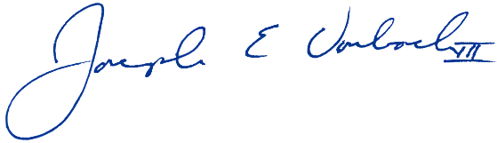
Joseph E Vorbach III, PhD, MEd
Superintendent
Office of Catholic Schools

Catholic Diocese of Arlington
200 North Glebe Road, Suite 503
Arlington, VA 22203
703-841-2519
arlingtondiocese.org

